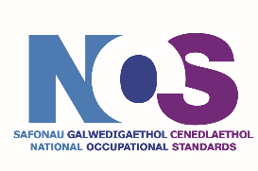
- There is a 10-working day timeline for quality assurer feedback and approval to be provided
- Tracked changes from the quality assurer are only required to be offered once. For any errors/issues identified, there is no guarantee that the same or similar errors are not present in the NOS unit or within the wider suite. Developers/translators are required to check all units and make any necessary amendments
Welsh NOS Quality Assurance Process – June 2025

